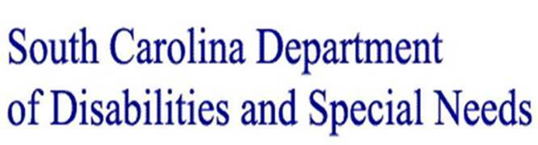

Emergency Operations Center (EOC): eoc@ddsn.sc.goV; 803-898-9754
SituatioNAL REport No. 27 date: July 7, 2020
Event Covid-19 pandemic

- SCDHEC Guidance Regarding Reasonable Access to Support: (Click Here)

Today, the South Carolina Department of Health and Environmental Control (DHEC) published guidance regarding reasonable access to support persons during the COVID-19 pandemic. The memorandum applies to ambulatory surgical facilities, intermediate care facilities for individuals with intellectual disabilities (ICFs-IID), hospices, hospitals, and renal dialysis facilities.

- Provider Relief Fund: Medicaid & CHIP Provider Distribution: (Click Here)

Today, Health Resources & Services Administration (HRSA) released a new fact sheet for Medicaid and CHIP Providers that is now available on the Provider Relief Fund website. Please feel free to share this, as well as the Medicaid and CHIP Provider resources below, with relevant stakeholders and trade associations. Also note, HRSA is hosting a Webinar on Wednesday, July 8 from 4-5pm ET discussing the Medicaid and CHIP distribution and application.
Pre-register for the webcast is encouraged.

- CMS Issues FAQs Relating to Retainer Payments, Appendix K, Other Issues (Click Here)

The new FAQs include detail new guidelines for the use of retainer payments under 1915(c) waivers and in other HCBS authorities, length of Appendix K approvals, provisions for telehealth and personal protection equipment (PPE), clarification regarding fair hearings, and modifications to money follows the person demonstration programs.

- ABLE SC COVID-19 Kits Available

Complete this quick form to request a COVID-19 kit for individuals with disabilities and members of their household: https://bit.ly/covidkitform. Kits include the following: washable black masks, blue single use masks, toilet paper, pandemic kit, face shield (available upon request), cleaning solution, hand sanitizer, hand soap and paper towels.
- World Health Organization (WHO) Infection Prevention & Control Courses

The World Health Organization (WHO) created an interactive, web-based, knowledge-transfer platform offering online courses to improve the response to health emergencies. The platform, called “OpenWHO,” avails value added training to agencies providing healthcare and their stakeholders potentially life-saving knowledge and training in a web accessible, self-paced format consumable by large numbers of frontline healthcare workers, individuals receiving care, and other stakeholder. To learn more, click here.

- CDC-Training for Healthcare Professionals: (Click Here)

The Center for Disease Control & Prevention (CDC) archived webinars and training materials to assist healthcare professionals respond to the COVID-19 pandemic. Webinars accessible through this site include instructional videos on how to properly don and doff personal protection equipment (PPE) and practices to prevent and control the spread of COVID-19.

- Direct Support Workforce and COVID-19 National Survey 2020 (Click Here)

The University of Minnesota's Institute on Community Integration and the National Alliance for Direct Support Professionals collaborated to lift up the voice of the direct support workforce. The aim of this study was to gather evidence about the experiences of those providing direct support during the COVID-19 pandemic and to inform efforts to better prepare for future waves of this pandemic.

- OSHA Guidance-COVID-19 Frequently Asked Questions (Click Here)

The U.S. Department of Labor’s Occupational Safety and Health Administration (OSHA) published June 10, 2020, a series of frequently asked questions (FAQs) and answers regarding the use of masks in the workplace.

The new guidance outlines the differences between cloth face coverings, surgical masks and respirators. It further reminds employers not to use surgical masks or cloth face coverings when respirators are needed. In addition, the guidance notes the need for social distancing measures, even when workers are wearing cloth face coverings, and recommends following the Centers for Disease Control and Prevention’s guidance on washing face coverings. These frequently asked questions and answers mark the latest guidance from OSHA addressing protective measures for workplaces during the coronavirus pandemic.

